**EXPERIMENT NO:-5**

* **AIM:** To design and test 4-bit Binary to Gray and Gray to Binary Converter circuits.
* **APPARATUS:** Logic trainer, LED’s, Digital IC 7486, Connecting wires.

* **THEORY:**

Computers and other digital circuits are required to handle data that may be numerical alphabet or special character. Since digital circuit in binary fashion, the numerical, alphabets and other special characters are required to be converted into binary format. There are various possible ways of doing this, which is called encoding. Some commonly used binary codes are BCD, Excess-3 and Gray etc.

Many physical systems provide continuous data at their output. This data must be converted in to digital form before they are applied to a digital system. Continuous analog information is converted to digital form by means of analog to digital converter. Here it is useful to use the reflected (or gray) code to represent digital data converted from analog data. The advantage of reflected code over pure binary number is that the reflected code changes only be one bit as it proceeds from one number to the next

**Binary to Gray and Gray to Binary:**

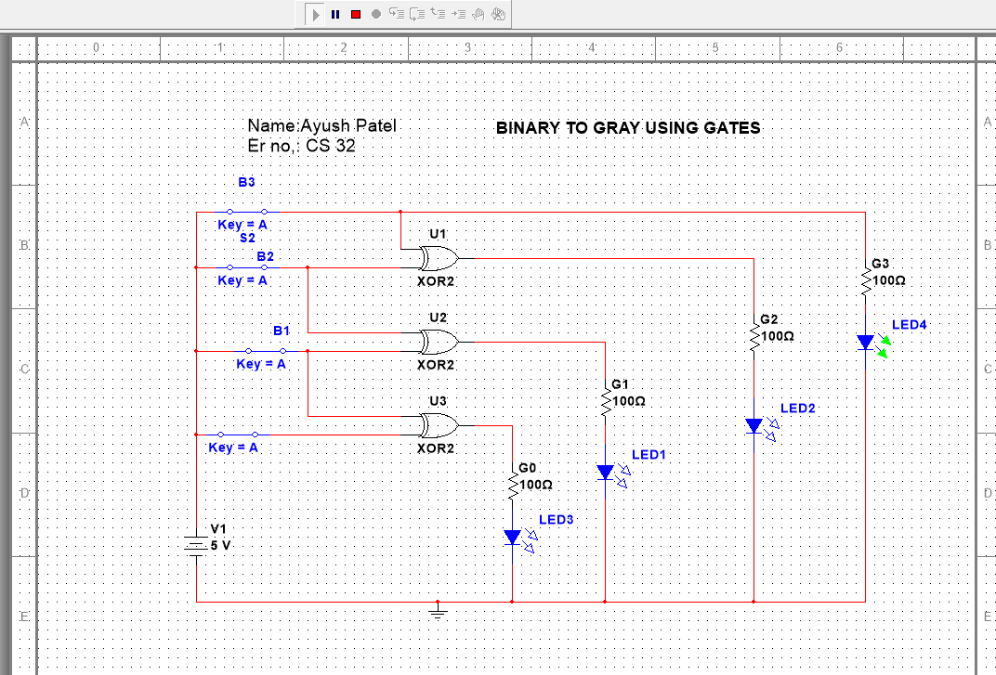(It includes circuit description, truth table, circuit diagram and logical explanation.)

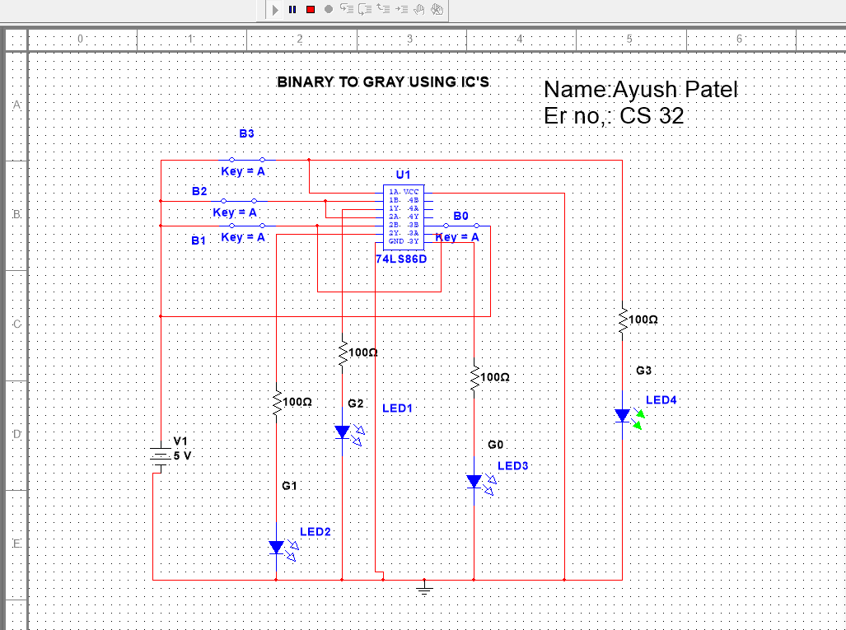

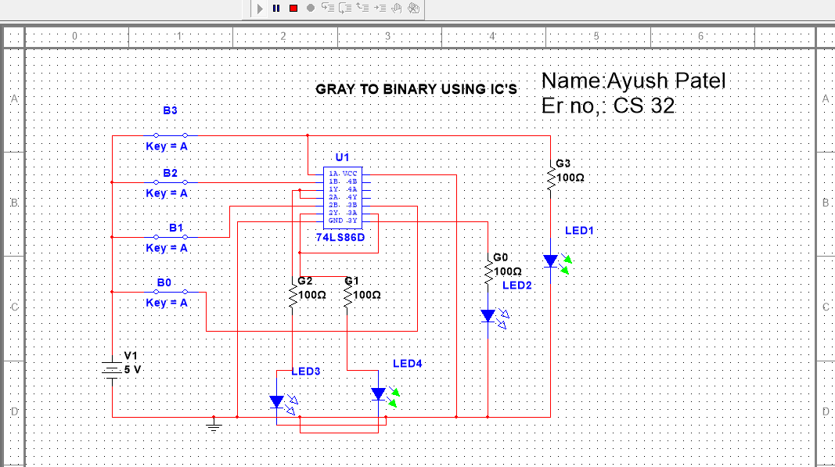

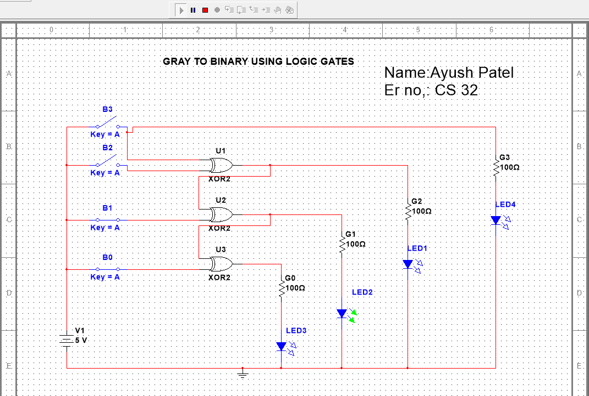

* **PROCEDURE:** 
  1. Write down the code conversion table, simplify Boolean function for each bit using K-map.
  2. Select appropriate ICs to realize the simplified Boolean function.
  3. Switch ON the power supply.
  4. Apply appropriated set of inputs and observe the output.

* **CODE CONVERSION TABLE:**

|  |  |  |  |  |  |  |  |  |
| --- | --- | --- | --- | --- | --- | --- | --- | --- |
| **BINARY** | | |  |  |  | **GRAY** | |  |
| **B3** | **B2** | **B1** | **B0** | **G3** | **G2** |  | **G1** | **G0** |
| **0** | **0** | **0** | **0** | **0** | **0** |  | **0** | **0** |
| **0** | **0** | **0** | **1** | **0** | **0** |  | **0** | **1** |
| **0** | **0** | **1** | **0** | **0** | **0** |  | **1** | **1** |
| **0** | **0** | **1** | **1** | **0** | **0** |  | **1** | **0** |
| **0** | **1** | **0** | **0** | **0** | **1** |  | **0** | **0** |
| **0** | **1** | **0** | **1** | **0** | **1** |  | **0** | **1** |
| **0** | **1** | **1** | **0** | **0** | **1** |  | **1** | **1** |
| **0** | **1** | **1** | **1** | **0** | **1** |  | **1** | **0** |
| **1** | **0** | **0** | **0** | **1** | **0** |  | **0** | **0** |
| **1** | **0** | **0** | **1** | **1** | **0** |  | **0** | **1** |
| **1** | **0** | **1** | **0** | **1** | **0** |  | **1** | **1** |
| **1** | **0** | **1** | **1** | **1** | **0** |  | **1** | **0** |
| **1** | **1** | **0** | **0** | **1** | **1** |  | **0** | **0** |
| **1** | **1** | **0** | **1** | **1** | **1** |  | **0** | **1** |
| **1** | **1** | **1** | **0** | **1** | **1** |  | **1** | **1** |
| **1** | **1** | **1** | **1** | **1** | **1** |  | **1** | **0** |

* **CONCLUSION:**

**By doing this practical we verify 4-bit Binary To Gray and Gray to Binary Converter circuits**